

**Wellness House Walk Challenge**

We did it we made it to the CN Tower in no time!!

WE are walking on to our next stop:

CN Tower to Lake Kawartha = **162 KM**

**How to Join**

* Each week count your steps (walking around the house, walking outside or sitting and marching.) Any step you take counts!
* On Fridays count up all your steps from the week and email them to Etta at [atravassos@josephbranthospital.ca](mailto:atravassos@josephbranthospital.ca)
* You will receive weekly email updating you on our progress

Total Steps = **226,800**

**Lake Kawartha**

[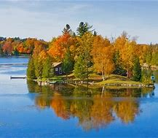](https://www.bing.com/images/search?view=detailV2&ccid=ofVNhvjd&id=40AF3C510F5D9CA215C3B6982E75F331EF421BF4&thid=OIP.ofVNhvjdO-NCNVOwNRtEzQHaFF&mediaurl=http://tripsetter.com/wp-content/uploads/2012/06/Kawartha-Lakes.jpg&exph=496&expw=722&q=lake+kawartha+ontario&simid=608004645692900142&ck=1310FD1DDCB9A8B43F2FFB6BE4470232&selectedIndex=3&FORM=IRPRST)





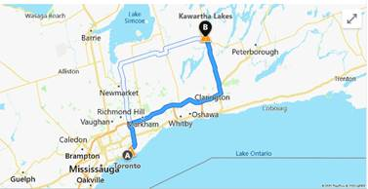



**Total Steps**

**226, 800**

1Km = an average of 1,400 steps